Project description
Approach a Giant Head and it senses your presence and will talk about the Dog Dream, sing a Chordettes song or produce bird songs. After that, it sends a radio signal to the next head which may tell you that it has a Radio Installed and you can call it "radio-active" or a "radio head". Who's to say what it will do? The next Head may mock it, etc.
The circuits and program used in the Giant Heads allows you to string together Arduinos wirelessly using really inexpensive 433 MHz radios. This one way communication is slow but simple. If you're looking to make an interactive project, This method may work for you.
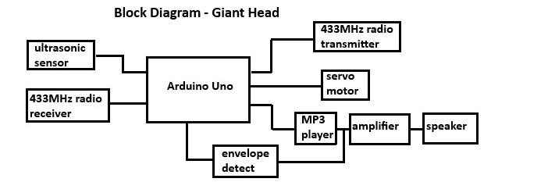
The Arduino responds to either the ultrasonic sensor or an incoming radio signal by enabling the MP3 player. The servo-driven mouth of the Giant Head sings or talks along. This is accomplished by the audio output from the MP3 player goes into a sound detector board which outputs the envelope of the audio signal. This envelope is fed into the A/D converter on the Arduino and is used to generate a PWM signal for the servo motor.
After the audio clip has finished playing, the RF transmitter sends a digital word to the next Giant Head. Each 433Mhz radio transmitter is paired to the radio receiver in the next Giant Head. The three Giant Heads are linked in a loop with these radios.
Each giant head has four different possible responses when you approach. They alternate each time you approach. For example the Skull will tell you "I'm sorry, but you can't stand here; this is where the dogs come ashore." when you first approach it. The second time "Look! It's the dogs....." and so on. Once the message trigged by the ultrasonic sensor has played, the Head transmits a digital word (either 001 or 100) to the next Head, in this case the Alien Head.
The Giant Heads are upcycled from an earlier project. They would sing "Mr. Sandman" and "Lollipop" upon request. The mechanism was so primitive I will not describe it out of embarrassment. .

Giant Heads in previous life
If you want to build your own Giant Heads or similar, the Heads are made of Celluclay (a commercial product similar to paper-mache) applied to a wire mesh and plywood form. The form is supported by a 2 X 2. The jaws are on a pivot and have a spring pulling them closed. The Heads are painted with acrylics.
Since the circuitry and programs are probably of more interest than the Giant Heads, I'll describe the circuits and programs.
To make the electronics on this project follow these steps:
- Modify the Sparkfun Sound Card
- Pair the transmitters and receivers
- Install components on the breadboards and wire
- Copy sound clips to SD card, install in MP3 player
- Load programs & enjoy
Modify SparkFun Sound Card
The SparkFun sound detector is used to extract the envelope of the attenuated audio signal coming from the MP3 player. This envelope is converted to a digital value by the Arduino A/D converter and is used to calculate the pulse width of the servo drive signal. The servo drives the Giant Head mouth to open and close to the audio.
The sound card has a built-in microphone which is removed. The audio output of the MP3 player is attenuated and connected to the red and black wires.
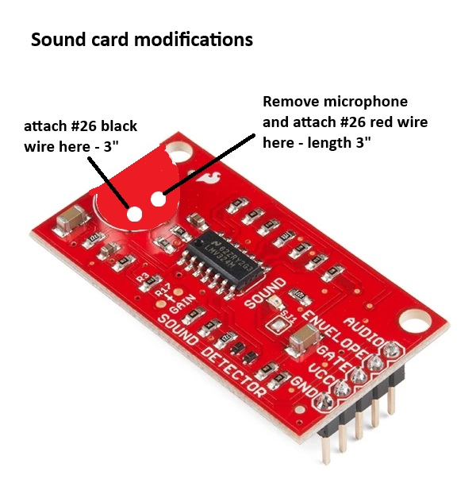
SparkFun Sound Detector
Pair Transmitters and Receivers
The key components in this project are the 433MHz radio receivers, The Qiachip RX480-E4 receivers have the capability of being matched with a Qiachip TX118SA-4 transmitter. This allows a super-easy way of ensuring that one Head talks only to the intended Head. The easiest way to pair each receiver with its transmitter is to build the circuit shown below. To match a receiver with a transmitter push the training switch 8 times; the LED on the receiver will flash 7 times. Next, push the training switch one time to put the receiver in momentary mode. Finally, push the transmit switch and the receiver LED will light, indicating that the two devices are paired. For more information on this process, consult the data sheets.
As you pair the devices, it is important to mark them so they can be installed in the correct circuits.
Devil Head RX3 TX1 -
Skull Head RX1 TX2
Alien Head RX2 TX3
A nice feature of these radios is that a receiver can be paired with two or more transmitters. Just don't reset the receiver by pushing the training switch 8 times when you're pairing a second receiver. I use this feature on a project linked to this one "Giant Pepper Boxes" . When one of the Giant Heads responds to the ultrasonic sensor and transmits a binary word, a receiver on one of the Pepper Boxes starts them on their interactive cycle.
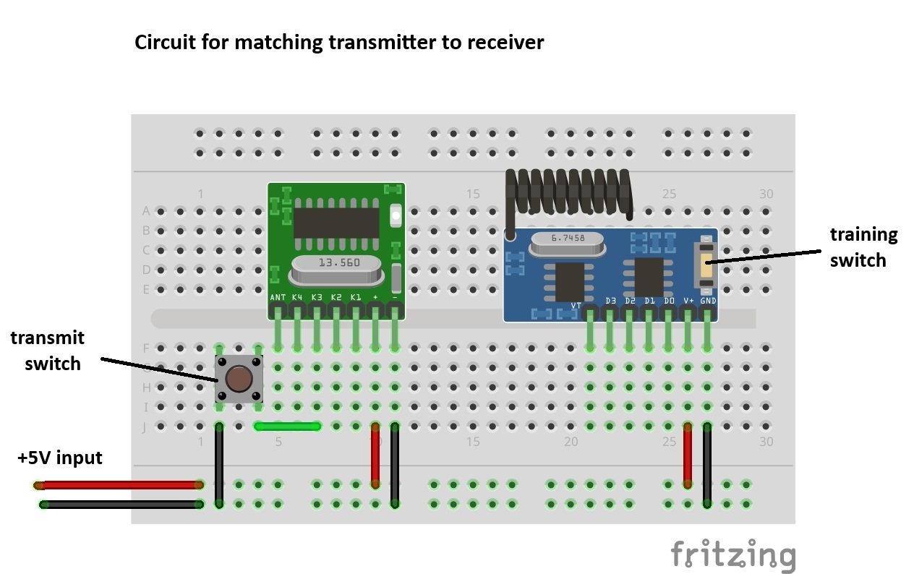
Install components in breadboards and wire
Depending on your particular project, you may choose to assemble the circuits in a different layout. Here's how I assembled them on the Devil Head. The servo is at the bottom and connects to the mouth of the Giant Head with a monofilament fishing line.
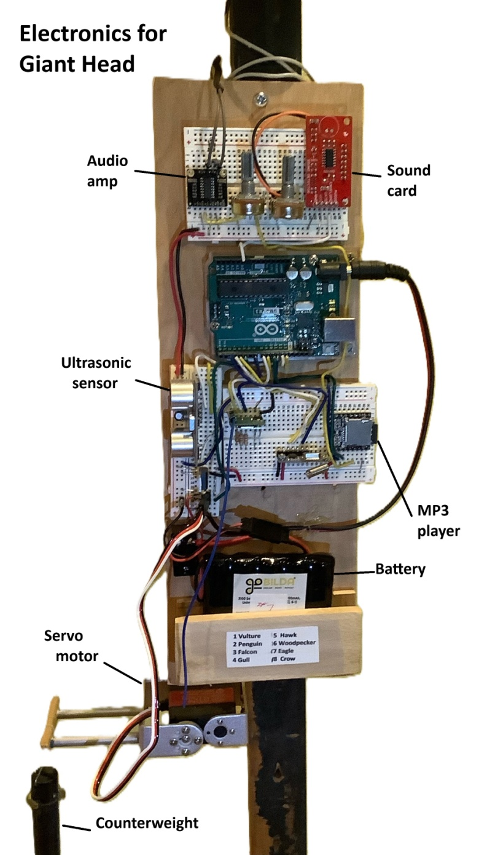
Giant Heads Electronics
To see where the wires go; here's a fritzing diagram. The sound card doesn't have a fritzing part so it's shown as an outline. 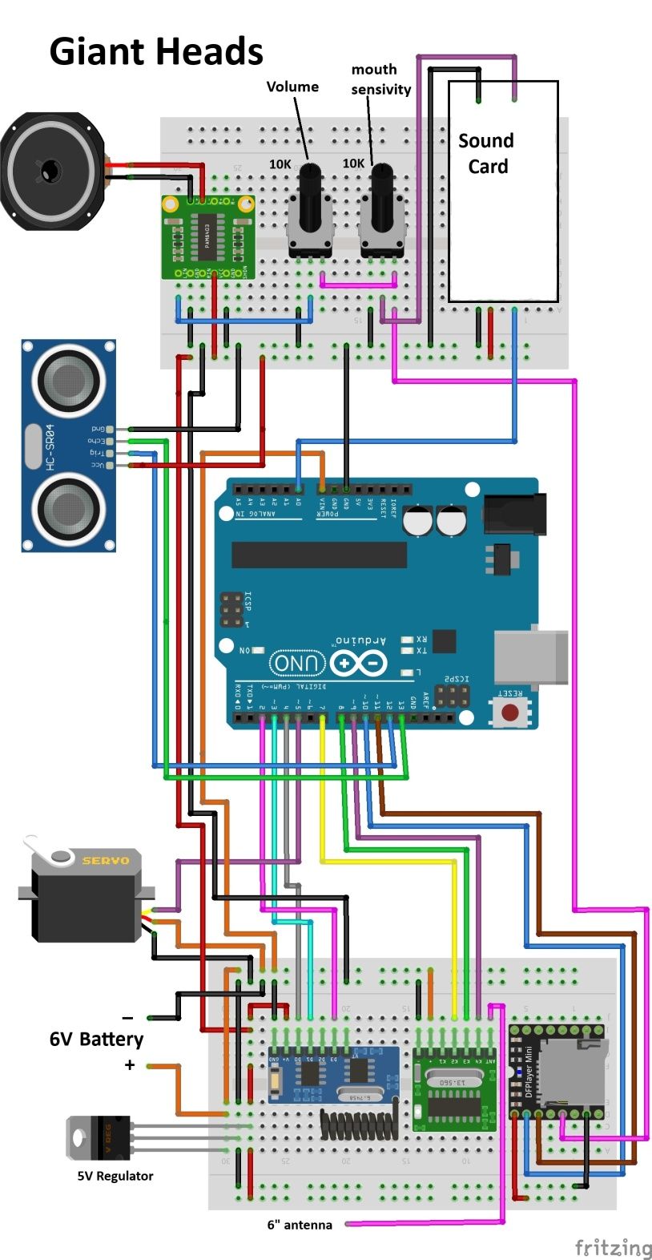
Copy sound clips to SD card, install in MP3 player
The sound clips are what makes this project fun! I recorded the sound clips in Audacity and copied them to the SD card. Be sure to put the sound clips in a file "MP3" so the player can find them.
Here's one of the 12 different interactions the Heads can have:
Alien - (triggered by ultrasonic sensor) plays Chordettes "Lay Down Your Arms" for 25 seconds - transmits to Devil
Devil - "I have a radio installed, I guess you could call me a Radio Head, or you could say I'm Radio Active" - Steve's voice - transmits to Skull
Skull - "That's not funny!" - Becky's voice - transmits to Alien
Alien - "You think it's funny when you say it!" - Becky's voice - transmits to Devil
Devil - "The life you lead can be your own." - Becky's voice - end sequence
Remember the sound clips must be stored on the SD card in a directory "MP3". A link to the scripts of the sound clips is $ here $ .
A link to the MP3 sound clips is $ here $ .
The four Chordettes songs for clips 0081 ("Mr. Sandman"), 0082 ("Lay Down Your Arms"), 0083 ("Lollipop"), and 0084 ("Never on Sunday") and not included since they are still under copyright. You can buy them on Itunes for very little, save them as MP3 and import them into Audacity. Once there' you can save them with the file numbers (0081, etc). Of course you can record your own MP3 clips in Audacity and have the Heads carry on any desired conversation!
Load programs and enjoy
There are three programs that are structurally identical but differ in the MP3 clips they play and when they play them. The program flow is: Ultrasonic sensor detects presence and then plays a sound clip and generates a PWM drive to the servo. After the sound clip plays, the Head transmits a digital word to the next head, which plays a sound clip, generates a servo drive PWM and then transmits to the next head, etc.
Program inputs- RF signal or ultrasonic detect
Program outputs- PWM signal to drive the servo motor, audio, RF transmit.
Internal parameters - pulseMax (maximum pulse width for servo, pulseMin (minimum pulse width for servo), mult used in formula for PW calculation, expt (used in formula to calculate pulse width of the servo drive.
There are several functions used in the program.
Function pulseGen generates 5 servo drive pulses
void pulseGen(int pulseLength) {
//pulsetrain with calcuated pulseLength
for (i= 0; i < 5;i++) {
digitalWrite(MOUTH, HIGH); //start servo pulse
delayMicroseconds(pulseLength);
digitalWrite(MOUTH, LOW);
delay(20);
}
}
Function center positions the mouth when audio is off
void center(int pulseCen) {
for (i= 0; i < 10; i++) {
digitalWrite(MOUTH, HIGH); //start servo pulse
delayMicroseconds(pulseCen);
digitalWrite(MOUTH, LOW);
delay(20);
}
}
Function servo calculates the servo pulse length based on the audio envelope input voltage. The program limits the maximum and minimum pulse length so that the servo driving the mouth doesn't go too far. The maximum and minimum values depend on the applicaion.
void servo(int val0 , int dur) {
//________________ __________________pulse generator (adjust k for audio length
for (k=0; k<dur; k++) {
val0 = analogRead(0); //calculate pulseLength and limit its range
pulseLength = pulseMin+ mult*pow(val0, expt);
if (pulseLength< pulseMin) pulseLength = pulseMin;
if (pulseLength> pulseMax) pulseLength = pulseMax;
pulseGen(pulseLength); // 5 pulse generator
}
center(pulseCen); // center the servo
}
Function transmit is used for one binary digit (100. 010, 001).
void transmit(int VX, int VY, int VZ) {
for (i=0; i<10; i++) {
if (VX==HIGH) {
digitalWrite(T0, LOW);
delay(50);
digitalWrite(T0, HIGH);
delay(400);
}
if(VY==HIGH) {
digitalWrite(T1, LOW);
delay(50);
digitalWrite(T1, HIGH);
delay(400);
}
if(VZ==HIGH) {
digitalWrite(T2, LOW);
delay(50);
digitalWrite(T2, HIGH);
delay(400);
Function xmit2 is used for two binary digits (110, 101, 011).
void xmit2(int VX, int VY, int VZ) {
for (i=0; i<5; i++) {
if (VX==HIGH) {
digitalWrite(T0, LOW);
delay(50);
digitalWrite(T0, HIGH);
delay(400);
}
if(VY==HIGH) {
digitalWrite(T1, LOW);
delay(50);
digitalWrite(T1, HIGH);
delay(400);
}
if(VZ==HIGH) {
digitalWrite(T2, LOW);
delay(50);
digitalWrite(T2, HIGH);
delay(400);
Function xmit3 is used for three binary digits (111).
void xmit3(int VX, int VY, int VZ) {
for (i=0; i<3; i++) {
if (VX==HIGH) {
digitalWrite(T0, LOW);
delay(50);
digitalWrite(T0, HIGH);
delay(450);
}
if(VY==HIGH) {
digitalWrite(T1, LOW);
delay(50);
digitalWrite(T1, HIGH);
delay(450);
}
if(VZ==HIGH) {
digitalWrite(T2, LOW);
delay(50);
digitalWrite(T2, HIGH);
delay(450);

